**Search a byte in is a string**

DATA SEGMENT

STRING1 DB 11H,22H,33H,44H,55H

MSG1 DB "FOUND$"

MSG2 DB "NOT FOUND$"

SE DB 33H

DATA ENDS

PRINT MACRO MSG

MOV AH, 09H

LEA DX, MSG

INT 21H

INT 3

ENDM

CODE SEGMENT

ASSUME CS:CODE, DS:DATA

START:

MOV AX, DATA

MOV DS, AX

MOV AL, SE

LEA SI, STRING1

MOV CX, 04H

UP:

MOV BL,[SI]

CMP AL, BL

JZ FO

INC SI

DEC CX

JNZ UP

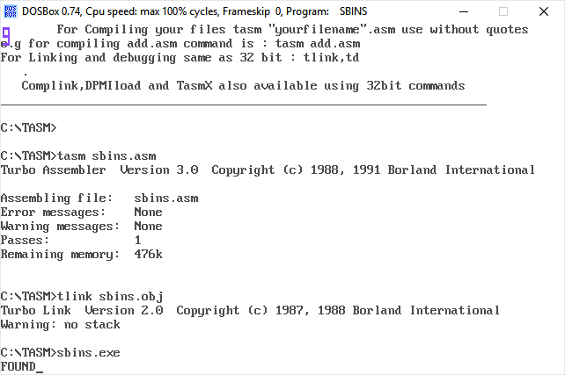PRINT MSG2

JMP END1

FO:

PRINT MSG1

END1:

INT 3

CODE ENDS

END START